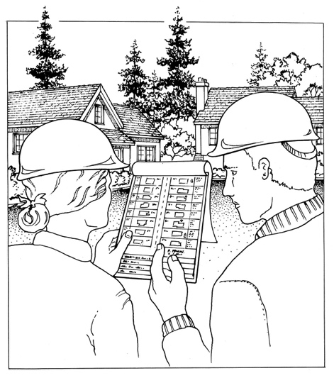

The reality is –

as a neighborhood we may need to respond to fire, injuries, and leaking natural gas during disaster. This meeting will help us know how. Please come.

Meeting Reminder:

“MYN” Map Your Neighborhood

Disasters, by definition, are events that overwhelm police, fire, and medical 911 emergency responders.

MYN helps us organize a timely response to disaster when 911 is unavailable. All of us, working together, can reduce the serious consequences of disaster in our neighborhood.

• We will learn a 9-step Neighborhood Response Plan that immediately helps us know what to do – both at home and in the neighborhood – to respond to injuries, leaking natural gas, and assisting people who may be alone and frightened. The process is proven, fun, and easy.

• We will identify the skills and equipment each neighbor has that are useful in an effective and timely disaster response.

• We will map our neighborhood’s natural gas meters and propane tank locations so we can quickly respond to leaking gas and reduce the threat of fire.

We will all go home with a neighborhood map, contact list, and skills and equipment inventory.

**What is a disaster?**

**Why MYN?**

**What will we do?**

**BONUS:**

*DATE:*

*TIME:*

*PLACE:*

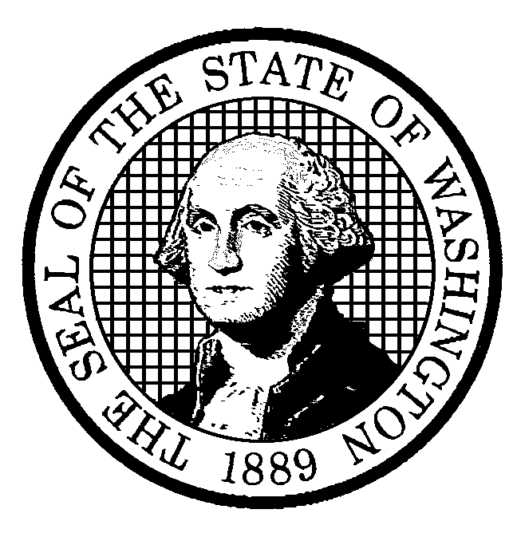

For more information contact:

Name:

Phone:

Email: